**Practical-4**

**Aim:**

Create Javascript Object of Spoural Registration User input and Display the Object Details on Webpage(Table)   
Create Car Object and Its methods like isFuelType(CNG, Petrol, Diesel, Hybrid), isType(like SUV, Hatchback,Luxury), isBrand(like BMW, Audi, Tata, Mahindra)  
Demonstrate : this keyword in constructor, method etc.

**Source Code:**

**-----HTML Code-----**

<!DOCTYPE html>

<html lang="en">

<head>

    <meta charset="UTF-8">

    <meta http-equiv="X-UA-Compatible" content="IE=edge">

    <meta name="viewport" content="width=device-width, initial-scale=1.0">

    <title>Document</title>

    <style>

        body {

            background-color: aquamarine;

        }

        #bike {

            width: 250px;

            height: 250px;

            border: 1px solid #000;

            border-radius: 3%;

            background-color: #fff;

        }

        #bike {

            width: 250px;

            height: 250px;

            border: 1px solid #000;

            border-radius: 3%;

            background-color: #fff;

        }

        #car {

            width: 250px;

            height: 250px;

            border: 1px solid #000;

            border-radius: 3%;

            background-color: #fff;

        }

        #phone {

            width: 250px;

            height: 250px;

            border: 1px solid #000;

            border-radius: 3%;

            background-color: #fff;

        }

    </style>

</head>

<body>

    <script src="Practical_4.js"></script>

    <h1 align="center">String Demo</h1>

    <div id="idshowMsg"></div>

    <!-- <button onclick></button> -->

    <h2>Click On the Image to get the Information</h2>

    <table>

        <tr>

            <td>

                <img src="BMW_Week_4.webp" id="bike" alt="BMW Icon" onclick="bike()">

            </td>

            <td>

                <img src="Maclaren_Week_4.webp" id="car" alt="Maclaren Image" onclick="car()">

            </td>

            <td>

                <img src="Iphone_Week_4.jpg" id="phone" alt="Iphone_Week_4" onclick="phone()">

            </td>

        </tr>

    </table>

    <table id="tab" border="2">

    </table>

</body>

</html>

**-----JavaScript Code-----**

// // const prompt = require("prompt-sync")();

// const name = 'Dishant';

// // const smstr = "Welcome " + name +" to Charusat"; -- old syntax

// const smstr = ` Welcome ${name}, to CHARUSAT`;

// console.log(smsstr);

// document.getElementById("idshowMsg").textContent = smstr;

// const studentObj = {

//     name: "Chauhan Dishant",

//     age: 30,

//     gender: "Male",

//     address: " Shivaji Nagar , street no.3, Savarkundla",

//     phone: "7041652332",

//     email: "dishantchauhan40@gmail.com",

//     course: "AWS",

//     year: 2022,

//     displayData: function () {

//         return ` Your name is %{this.name} and age is ${this.age}`;

//     }

// };

// console.log(typeof (studentObj));

// console.log(studentObj["name"]);

// console.log(studentObj.phone);

// for (key in studentObj) {

//     console.log(` key =${key} v=${studentObj[k]}`);

// }/

let cnt = 0;

console.log("connected");

function bike() {

    const BMW = {

        name: "BMW Sports Edition",

        brand: "BMW",

        price: "1200000",

        color: "Black",

        weight: "Heavy",

        type: "SuperBike",

        year: "2022",

    };

    display(BMW)

}

function car() {

    const Maclaren = {

        Model_name: "Maclaren GT Coupe",

        brand: "Maclaren",

        Fuel_Type: "Petrol",

        Max_Power: " 612 bhp @7500 rpm",

        Max_Torque: "630 Nm @ 5500 rpm",

        Mileage: "7 kmpl",

        price: "3.72 Crores",

        color: "organge",

        weight: "1466",

        Type: "SuperCar",

        year: "2019",

    };

    display(Maclaren)

}

function phone() {

    const Iphone = {

        Model_name: "Iphone 14 Pro Max",

        brand: "Apple",

        OS: "iOS 16, upgradable to iOS 16.2",

        RAM: "8 GB",

        Price: "169,900",

        weight: "240 grams",

        Storage_Capacity: "512 GB",

        color: "Purple"

    };

    display(Iphone)

}

function display(info) {

    if (cnt != 0) {

        document.getElementById("tab").innerHTML = null;

    }

    for (let i in info) {

        document.getElementById("tab").innerHTML += `<tr><td>${i}</td><td>${info[i]}</td></tr>`;

    }

    cnt++;

}

**Output:**

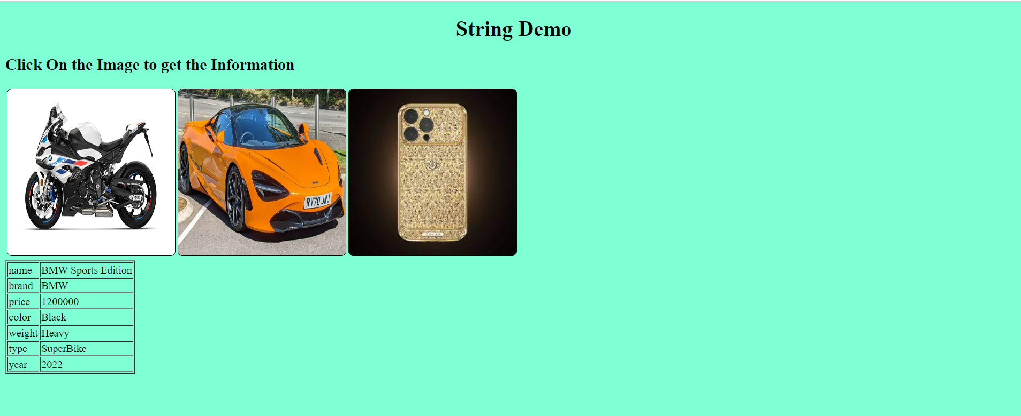

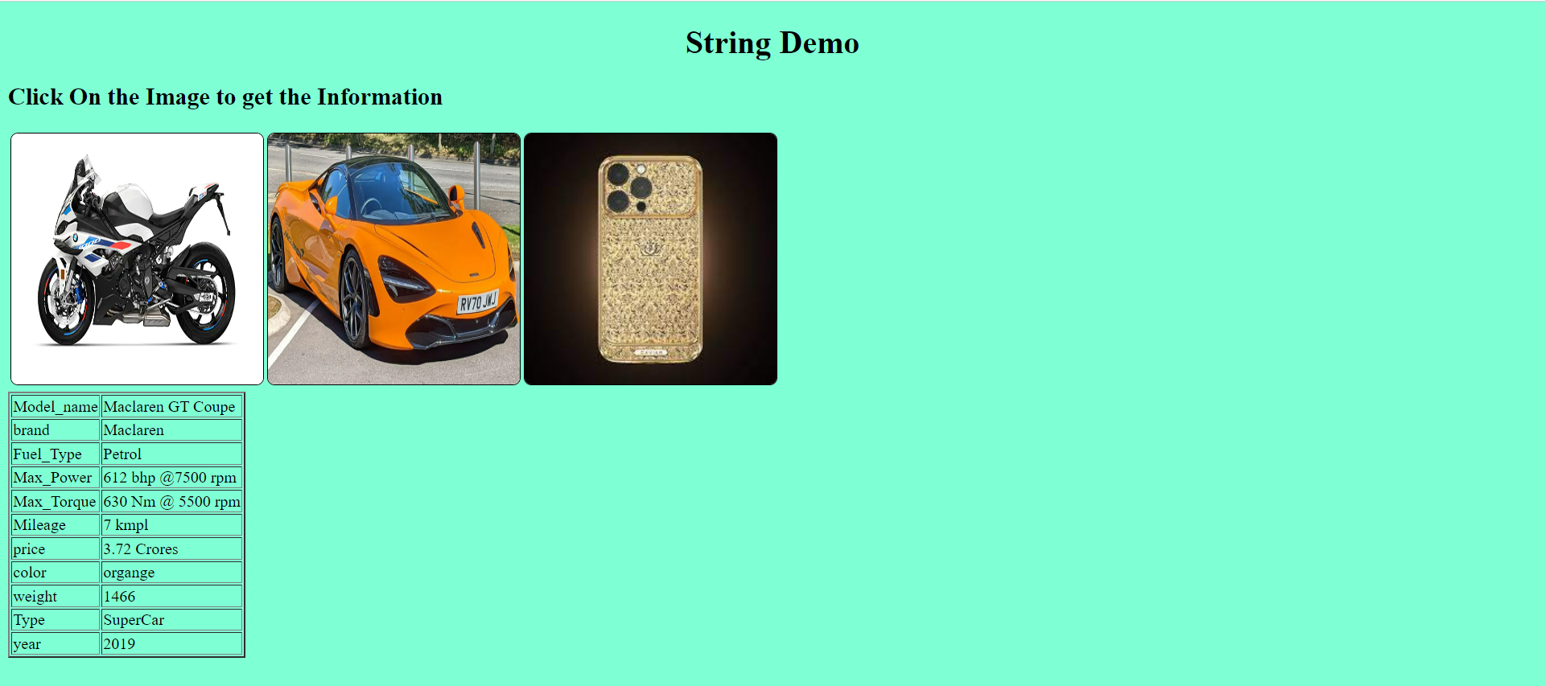

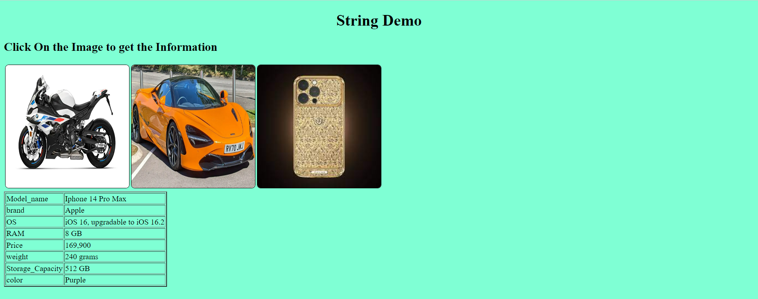

**Conclusion :**

In this practical I came to know about the concept of onclick() event listener and it’s working. I have also implemented the onclick() method on bike,car and on iphone and I have displayed it through the table.